# Project Build-A-Thon

# [SmartPracticeschool](https://github.com/SmartPracticeschool)/[SPS-6203-Build-an-Image-based-Nutrition-Analysis-Dashboard](https://github.com/SmartPracticeschool/SPS-6203-Build-an-Image-based-Nutrition-Analysis-Dashboard)

**Contents**

1. Introduction
   1. Overview
   2. Purpose
2. Literature Survey
   1. Existing Problem
   2. Proposed Solution
3. Theoretical Analysis
   1. Block Diagram
   2. Hardware / Software Designing
4. Experimental Investigations
5. Flow Chart
6. Result
7. Advantages and Disadvantages
8. Applications
9. Conclusion
10. Future Scope
11. Bibliography
12. Appendix
    1. Source Code

1. Introduction

"Fit India" slogan need to be followed by every citizen. Fitness depends on intake of food and exercise. Now-a-days, majority of people turn obese due to malnutritional foods. Technology use can make all age group people to understand the nutritional details of food they take irrespective of domain knowledge. In the current project we specify the role of technology to maintain fitness and make our task of hygiene intake of food.

* 1. Overview

Due to the improvement in people’s standards of living, obesity rates are increasing at an alarming speed, and this is reflective to the risks in people’s health. People need to control their daily calorie intake by eating healthier foods, which is the most basic method to avoid obesity. However, although food packaging comes with nutrition (and calorie) labels, it’s still not very convenient for people to refer. Mobile-based nutrient dashboard systems which can analyses real time images of meal and analyze it for nutritional content can be very handy and improve the dietary habits, and therefore, result in healthy life.

* 1. Purpose

Technology support makes it easier in order to read an image and classify the nutritional values of food items. Various Government websites are present to collect the food and nutrition specifications which makes the domain-expertize tasks easier. Later, technology can be used to identify the food and classify the food items in the images and then caption the nutrition values, for easy understanding.

1. Literature Survey
   1. Existing Problem

Food items are seen in super markets, retail vendors and at various supply chains. It is essential for the customer to easily understand the nutrition available in the food provided at fast food centres etc. If we take an image of food, it should help in detecting the nutrition in food. Currently, such provision is not seen easily.

* 1. Proposed Solution

This project aims at building a web App which automatically estimate food attributes such as ingredients and nutritional value by classifying the input image of food. Our method employs IBM Watson food model for accurate food identification and Food API's to give nutritional value of the identified food.

1. Theoretical Analysis
   1. Block Diagram

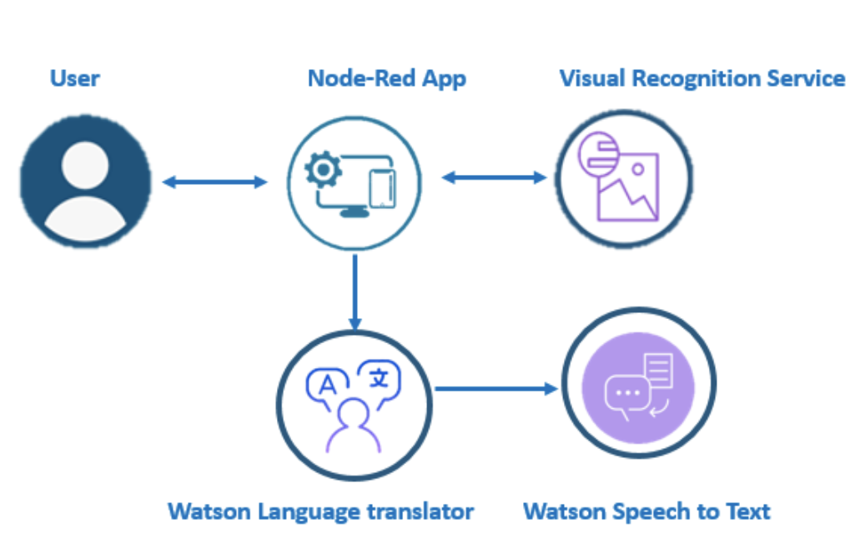

* 1. Hardware / Software Designing

Python, Python Web Frame Works, JSON

IBM Watson Visual Recognition

IBM Nodered

1. Experimental Investigations

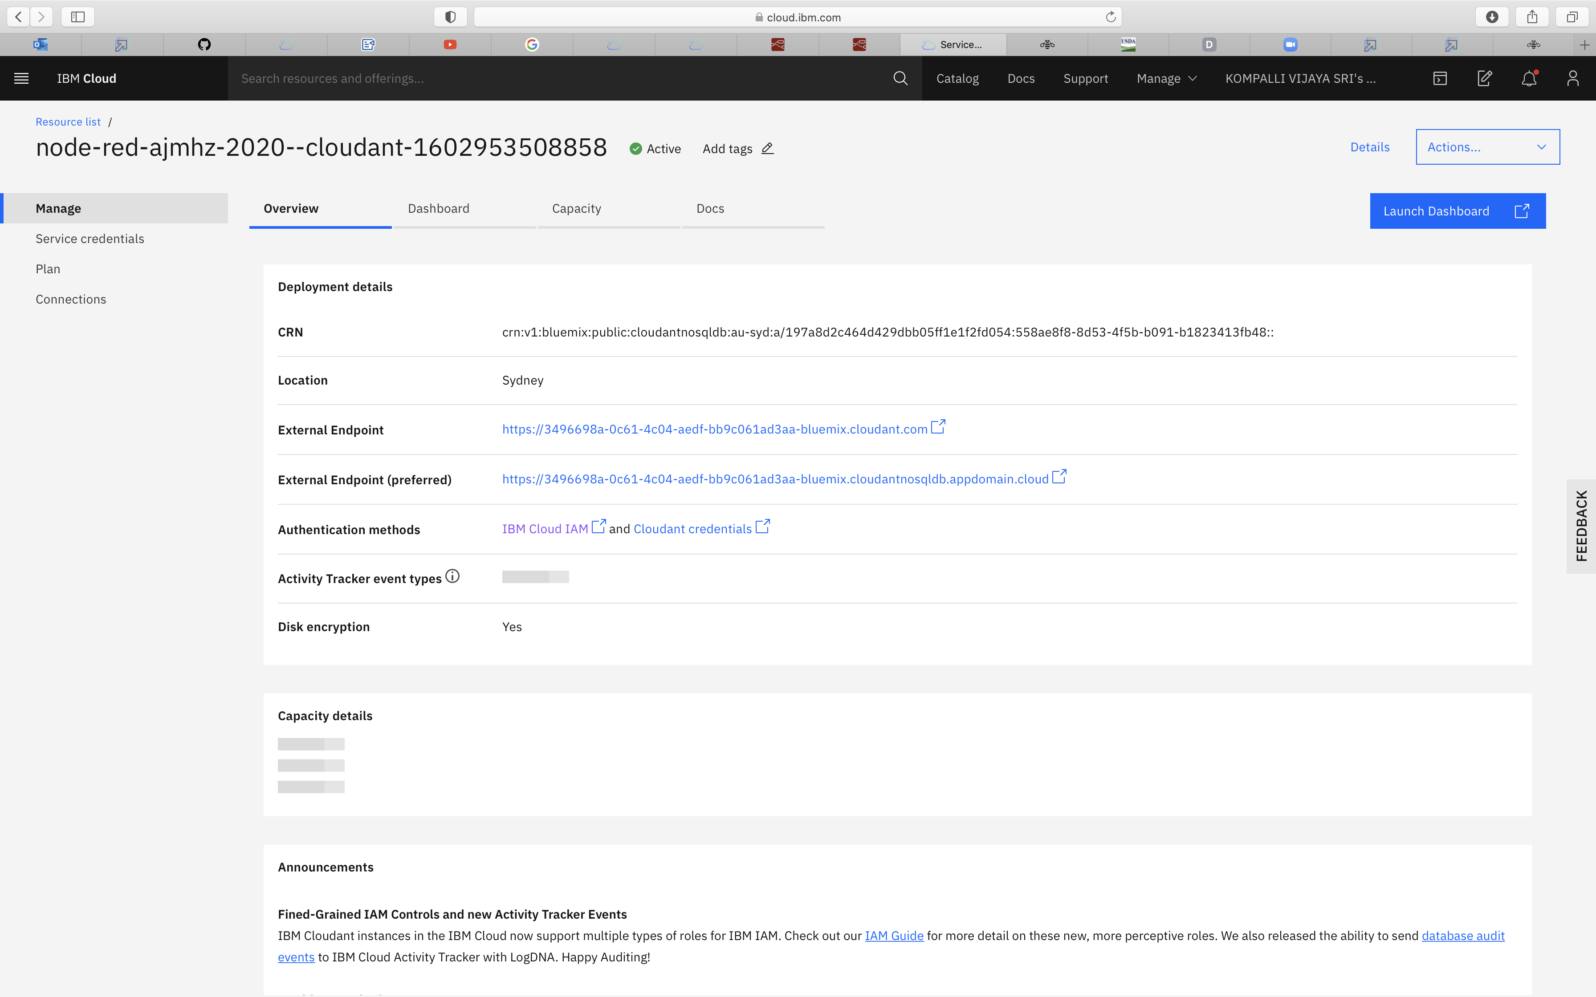

1. Flow Diagram

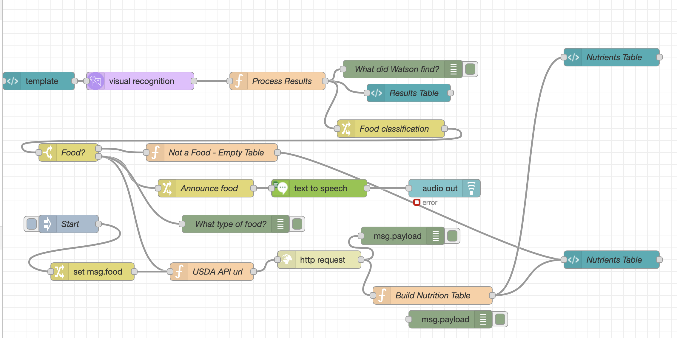

1. Result

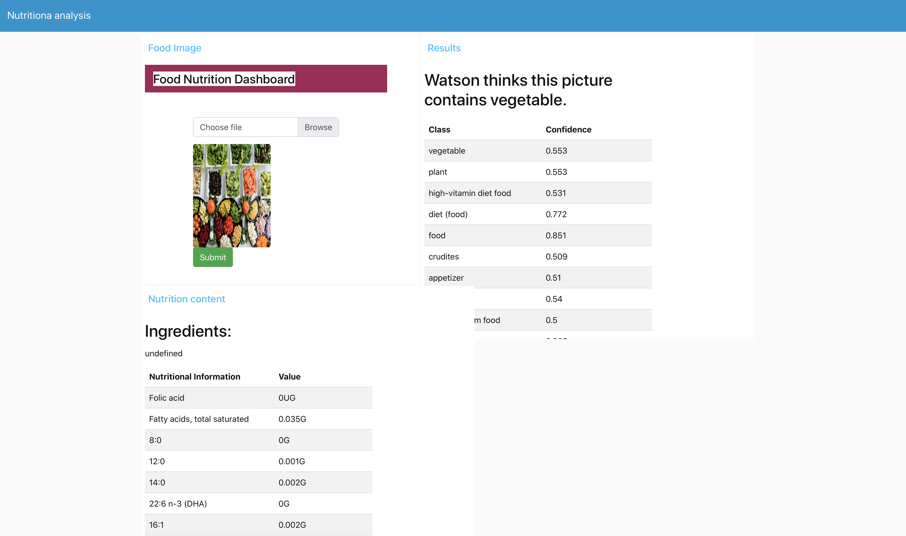

1. Advantages and Disadvantages

Advantages:

1. Easy to use
2. Nutrition Values known instantly

Disadvantages

1. Food item name and specific details missing
2. Than website App will be very useful and handy
3. Visual Recommendations of food preference to intake should be given for the use of children. For not to prefer **X ;**  For Presence good as **S**
4. Domain Knowledge standards resources need to be maintained.
5. Applications
6. In APP for daily use
7. Retail food sale recommendation charts
8. Conclusion

It is good to have instant clarification of healthy food intake. Image classification of various food items help to stay fit.

1. Future Scope

Can be made an app for daily and easy handling and understanding of all age group people.

1. Bibiliography

https://developer.ibm.com

https://fdc.nal.usda.gov/api-key-signup.html

https://smartinternz.com/Student/badge_workspace/6203

1. Appendix

Source Code

